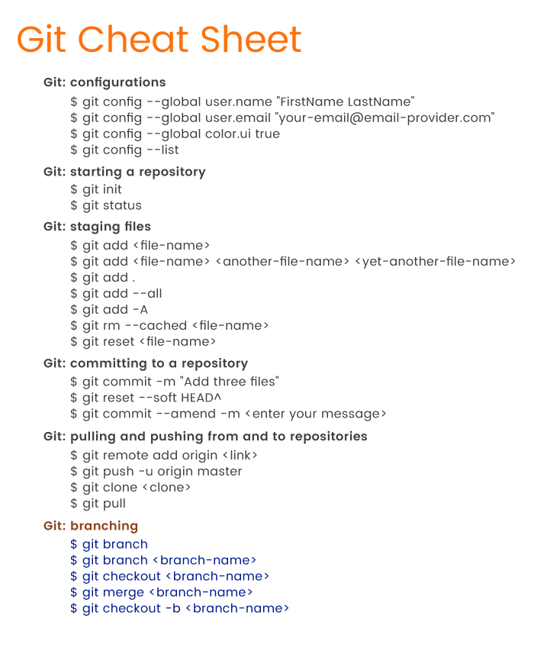
Personality questions

1.Tell me about yourself (not about the project)
I have been in QA for the past 3 years.

2. Why did you choose QA?
(I started because once I needed to make a website for my business. When the site was made, I ran into incorrect work of my site. When trying to talk to the developers, what they do to make the site work stable. It didn’t work. I decided that I would try to find and fix what was in my power. This is how I got introduced to testing.)

Tech questions

1.QA & QC - QA (The basic goal is to prevent bugs in a timely manner.)
QC (The goal is to find and remove bugs)

2. Verification & Validation:

Validation - is the process of checking that the system meets the requirements and expectations of the customer “Did I build what I said I would?”

Verification is the process of checking that the software meets the requirements. We verified the software work as expected. “Did I build what I need?”

3. SDLC - The life cycle of software is a period of time that begins from the moment a decision is made on the need to create a software product and ends at the moment of its complete retirement.

4. User Story - a short statement of the user's intent and what the product should do for them.

5. How you create bug report?
- Title
- Environment
- Steps to reproduce
- Expected / Actual result
- Attachment

6. Release & Production

Production - it is about name environment, what is visible to all users.
Release - this is a constant process in every sprint when we have finished work on any updates and release them in production.

7. Test environment - infrastructure for preparing and conducting tests and interpreting results.

8. Test coverage - percentage of functionality tested by this set of checks.

9. Positive test - Data validation. Correct actions.

Negative test - Checking for incorrect data. Not correct Action.

10. Pass/Fail criteria - established rule. allowing you to determine whether the system passed this test successfully or unsuccessfully.

11. GIT Commands

12. TEST Cycle - A testing cycle is a defined period in time consisting of a start date, an end date, and a list of manual testers.

